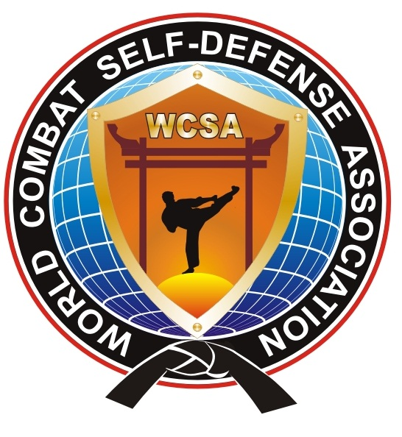
WORLD COMBAT

SELF–DEFENSE ASSOCIATION
_____________________________________________________________________

Corp. № 0400463637, USA, 302 High St. Ste. C36 Fair Lawn, New Jersey 07410
www.combatsd.com, e-mail: wcombatsd@gmail.com , secretary: +19175393782

Ladies and Gentlemen!

VI Martial Arts Olympics “East-West” will take place in St.Petersburg, Russia, from 25 to 29 April 2012. It is one of the biggest events in world of combat and martial arts sports. Over 8500 participants from more than 60 countries worldwide are expected to attend. As part of the Olympics, Intercontinental Tournament will be held: «Open Europe Cup-2012 of Combat Self-Defense».
On the 26th April, the International Conference «WCSA» will take place. One of the topics witch will be discussed is Combat Self-Defense – a new and modern trend in the sport of Mixed Martial Arts. To date, this style has become popular in Europe, Asia and America. In January 2012 the activities of «WCSA» was awarded with the Oscar at the World of Martial Arts Awards Ceremony (Atlantic City, USA).
The main topics covered in this conference are as follows:
• Decision of authority official representatives of «WCSA» by country;
• Distribution of liabilities among the governing bodies of «WCSA»;
• Establishing an executive committee;
• Establishment of a technical committee;
• Approval of the calendar of events.
The aim of the Association is the popularization of Combat Self-Defense among today`s Youth, the development of amateur and professional MMA sport with the promotion of amateur fighters into Combat League "WCSA".
The activity of «WCSA» and promotion of this style in your country - will create an additional drive to attract young people to try out the most popular martial arts. This will enable more effective cooperation and mutually beneficial relations between countries.
We look forward to your support and contribution to the development of the organization, submission of the official representatives to participation in the conference.

e-mail: wcombatsd@gmail.com

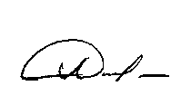
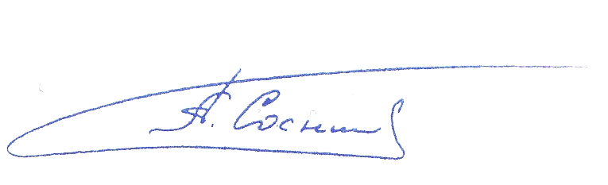
President WCSA, Dr RAFGAT ALTYNBAEV

Chairman WCSA ALEXANDER SOSNIN
(6 Dan/Degree)

